
GRAPHICS PACKAGE

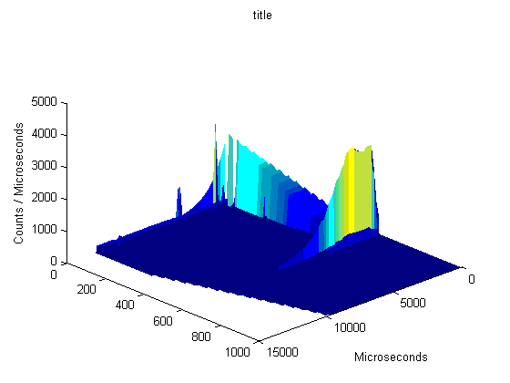
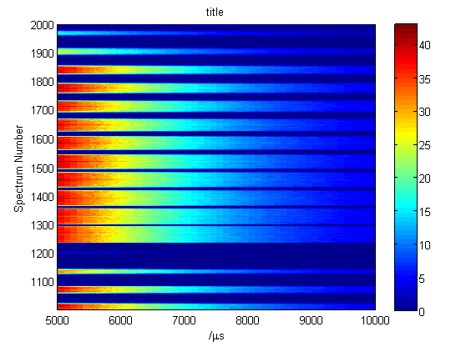
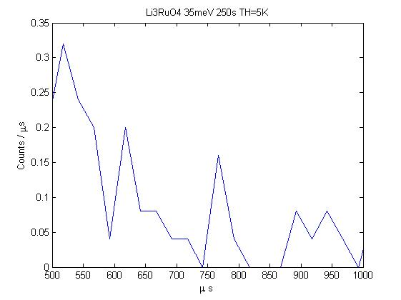

User Guide

Dean Whittaker

Table of Contents

1. Introduction and Installation 4
1.1 Getting Help in Matlab 5
2. Reading Data 6
2.1 Datasets 6
2.2 Reading From a RAW File 6
2.3 Reading from an ASCII file 7
3. Plotting Commands 7
3.1 One dimensional graphs 7
3.1.1 Overplotting 8
3.1.2 Plotting arrays of dataset_1d with one dimensional commands 8
3.1.3 Plotting dataset_2d data with one dimensional commands 9
3.2 Two dimensional graphs 9
3.2.1 Plotting arrays of data using two dimensional commands 9
3.3 Three dimensional graphcs 10
3.4 Optional Settings 10
3.4.1 Name Tags and Defaults 11
4. Pre-emptive Formatting 11
4.1 Setting Colours for Lines and Markers 12
4.2 Altering Line Properties 12
4.3 Altering Marker Properties 12
5. Retrospective Formatting 12
5.1 Changing Limits: 12
5.2 Changing Axes to Linear or Log: 13
5.3 Changing the aspect ratio 13
5.4 Finding points on a graph 13
5.5 Keep Figure 15
5.6 set_plot, set_axes, set_figure 15
5.7 Set legend (sl) 16
6. Other Commands 16
6.1 Reset Default 16
6.2 Reset All 16
6.3 gallnt (get all name tags) 17
6.4 gallh (get all handles) 17
6.5 undop (undo plot) 17
6.6 Color_slider 17
6.7 Rename 17
6.8 Fromplot 17
6.9 Set default property - sdp 18
6.10 Set User Preferences – sup 19
6.11 Check Figure – chkf 19
6.12 Get Handle – gh 19
6.13 Alias 20
7. FAQ and Support 20
7.1 Online Help 20
7.2 User Reference 21
7.3 FAQ 21
7.4 Technical Support 21

Introduction and Installation

GTK graphing package is a suite of tools to plot graphs from IXT datasets. This is a continuing project where routines are regularly being updated and new functionalities added. This is a command line driven program. A more detailed list of commands is given in the “User Reference” Document, which lists all user functions. Also note that the wiki (https://www.libisis.org) gives fully up to date documentation (and a known issues list).

To install GTK:

- Add the GTK files to any directory.

- Start Matlab

- On the matlab command prompt type

>> matlabroot

You should see something similar to :

C:\MATLAB6p5p1

Type:

>> which startup

You will see something like :

C:\MATLAB6p5p1\toolbox\local\startup.m

Note:

- If you do not get any response on this command, create startup by

>> edit startup.m

Select yes to create it
Inside this file put the statement

addpath (PATH WHERE GTK_Application is installed [see point 1] above for reference]);
gtk_init;

and save this file in directory

toolbox\local\

(this directory will be in matlab home, which can by obtained by matlabroot as shown in the above command)

- If you get a response on this command, proceed as follows

>> edit startup.m

Inside this file append as shown below

addpath (PATH WHERE GTK_Application is installed [see point 1]);
gtk_init;

and save this file in directory

As for example :

addpath 'C:\GTK_Application';
gtk_init;

- Exit the matlab session by typing exit on the command prompt

>>exit

- Start matlab again

- As a confirmation you must get this message
%-------------------------------------------------------------------------
Graphical Toolkit Started Successfully
%--------------------------------------------------------------------------
Note: If you do not get this message report it

Getting Help in Matlab

Online help for most user functions is available by typing:

>> help function

Where function is the name of the function that help is required for.

Many functions are shared between datasets, but a slightly different version of the function is used for each dataset. At the end of the help, there will be hyperlinks to these various versions contained in folders named after the dataset (IXTdataset_1d, IXTdataset_2d). For instance typing help smooth will give the following help:

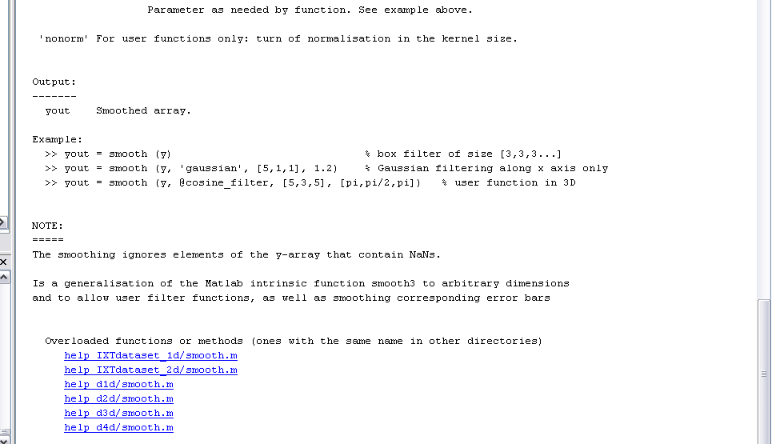

The hyperlinks will lead to the help for the specific dataset functions “smooth”. Sometimes these specific functions may have slightly different function calls or formats. Therefore, they may be worth looking at.

Reading Data

Datasets

There are several different datasets used within the ISIS software, the most important for GTK are dataset_1d and dataset_2d objects (full titles IXTdataset_1d and IXTdataset_2d respectively). These are objects which contain an abundance of information about the spectrum and data from the instruments, which is obtained from raw files.

The most important difference between the two is that a dataset_1d contains just x data and signal data while a dataset_2d also contains y data.

Reading From a RAW File

First the raw file must be read into a variable using the command

>> raw_variable = IXTisis_raw_file(‘full raw path’);

Data from the raw file can then be read into a dataset_2d object using the command

>> data = getspectra(raw_variable,[start:end]);

Where start is the first spectrum and end is the final spectrum to be read into the dataset. A dataset_1d object can be created from one spectrum by typing:

>> data = getspectrum(raw_variable, spectrum_number);

If the size of the raw file is required, then the command

>> nsp = geti(rawfile1,'NSP1');

can be used.

Example:

>> rawfile1 = IXTisis_raw_file('c:/RAW files/HET15958.RAW');
>> nsp = geti(rawfile1,'NSP1');
>> d2a = getspectra(rawfile1,[1:nsp]);
>> w1 = getspectrum(rawfile1,25);

Loads all spectrums from the HET15958 raw file contained in the folder c:\RAW files into a dataset_2d variable called d2a. Spectrum 25 is loaded into a dataset_1d spectrum called w1.

Reading from an ASCII file

Data can be read from ascii files using the following command:

>> w = read_ascii(‘filename’)

This will import the data from the x-y-e datafile into a dataset_1d object. By default the x and y units will be ‘unknown’ and the title the same as the filename. But these can be changed with optional property / value pairs, for instance

>> w = read_ascii(‘ex.dat’,’title’,’mytitle’,’xunits’,’myunits’)

This sets the data into the dataset and the properties are not the same as the plotting properties but some are used when plotting (for instance, the default title when plotting will be the title set into the dataset, the default x and y labels also come from the dataset).

With no filename given, or the filename is not recognised a window will open for you to select the file using a windows interface. This is easier to explore.

Plotting Commands

One dimensional graphs

Plot signal data against one dimension

>> dl (w1) Line plot of the data, joining bin centres
>> dm (w1) Mark points at bin centres
>> de (w1) Errorbars at bin centres
>> dh (w1) Histogram (boundaries for point data are drawn half way between the points)
>> dp Errorbar and Marker plot of data
>> dd Errorbar, Marker and Line plot of data

Overplotting
One dimensional graphs can be overplot with further data using the overplot commands when selected

>> pl (w2) overplot with a line
>> pm (w2) overplot with a marker
>> pe (w2) overplot with errorbar
>> ph (w2) overplot with histogram

These take the same optional arguments as other plotting functions.

Plotting arrays of dataset_1d with one dimensional commands
If plotting an array of dataset_1d objects using the one dimensional commands, each dataset_1d will be plotted as a line overlapping the others on the graph. Their order in the array determines the order in which they’re plotted. For instance,

>> acolor (‘red’, ‘blue’, ‘green’)
>> dl(ww)

Where ww is a 4 element array of dataset_1d objects, will plot lines of ww(1) in red, ww(2) in blue, ww(3) in green and ww(4) in red (see figure 1).

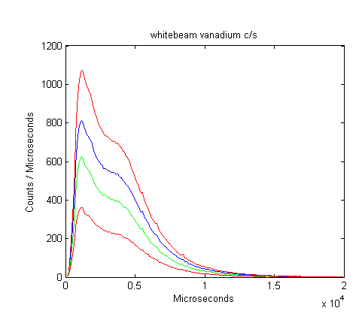
Figure 1: line plot of array of dataset_1d using acolor to set different colors

Plotting dataset_2d data with one dimensional commands
When a one dimensional plotting command is given a dataset_2d argument, the x and signal values for each given y value are plotted over each other (in the same way an array of dataset_1d is plotted).

Two dimensional graphs

Plot signal data against two dimensions

>> mp(ww) Multiplot array of dataset_1d using y = index in array
>> ds(d2a) Surface plot array of dataset_1d or dataset_2d
>> da(d2a) Area (colour) plot array of dataset_1d or dataset_2d

Plotting arrays of data using two dimensional commands
Arrays of dataset_2d objects can be plotted on a surface in two different ways (see figure 2):

- Combined - the data is combined and plotted as a single plot
- Separate - different plots are made on the same axes, one for each dataset.

When combined, the data is interpolated into evenly distributed points between the minimum and maximum values of all the data. The number of points used can be specified using the noxvalues or noyvalues options:

>> ds(ww, ‘noxvalues’,400, ‘noyvalues’, 30)

By default data is combined, this takes up more time and memory. To turn separation on, type:

>> ds(ww,’separation’,’on’)

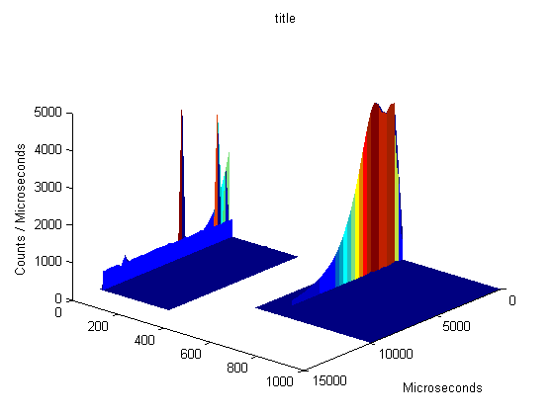
- (b)
Figure 2: A 2 element array of dataset_2d objects plotted using the surface command (a) combined and (b) separate

When using the area plot, dataset_2d objects will always be plotted over each other.

When plotting an array of dataset_1d objects using two dimensional commands, each dataset_1d will be given a y value of its index in the array and the array plotted as a dataset_2d using the same controls and commands.

Three dimensional graphcs

Plot signal data against three dimensions, input must be IXTdataset_3d.

>> sm(d3a)

This produces a sliceomatic plot (figure 3) . Sliceomatic is a stand-alone application and as such is not fully integrated into Libisis. The optional settings are severely limited and many commands simply will not work with sliceomatic plots. However, name-tags and kf still work and are the most useful tools.

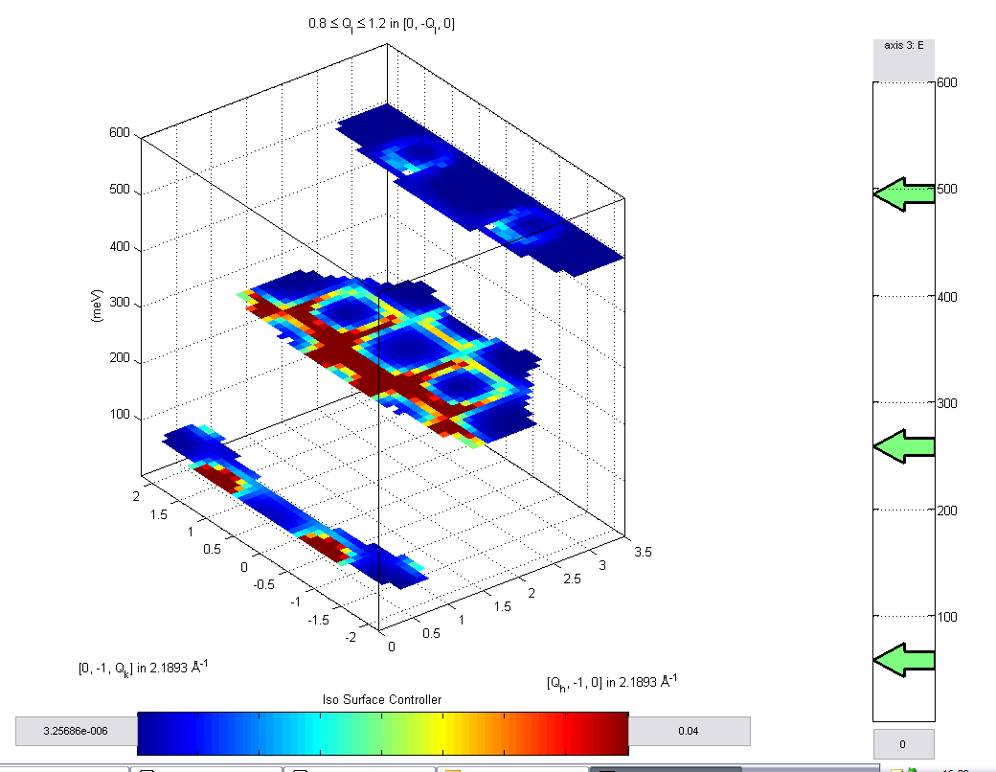
Figure 3: sliceomatic plot of IXTdataset_3d data.

Optional Settings

All of the plotting commands accept similar optional settings as input arguments, which must come in pairs. Below are several examples, see the user reference for a full list of valid options.

>> dl(w1,xlo,xhi,ylo,yhi)
>> dl(w1,xlo,xhi)
>> ds(d2a,xlo,xhi,ylo,yhi,zlo,zhi)
>> dl(w1,’color’,’green’,’title’,’myplot’)
>> da(w1,’zlim’,[0,0.1])

Quick Tip: An underscore (_) in a title or label makes the following letter subscripted. Other LaTeX commands can also be used.

Name Tags and Defaults
Names and tags are used to identify plots and define properties for them. Each plot with the same name and tag will have the same behavior and default values. Names are seen in the title bar of the plot, while tags are hidden from the user. When setting properties preemptively, name tags can be given so that only the properties of particular plots are changed. This can prove useful when dealing with large numbers of plots.
One can assign plots a name and tag easily by typing
>> dl(w1, 'name', 'myname', 'tag', 'mytag')
or
>> [fighandle] = ds(w1)
>> rename(fighandle, 'myname', 'mytag')
By default, each plot "type" has a different name and all tags are blank.
Plot Type | Default Name
oned | 'default one dimensional plot'
area | 'default area plot'
surface | 'default surface plot'
multiplot | 'default multiplot'
Table 1: default names

Problems with LaTeX

All plots in libisis interpret LaTeX commands. Any symbols in titles or axes labels such as ^ and _ will be interpreted as formatting specifiers. Therefore, if you don’t want to use LaTeX in a string you should first pass it through avoidtex

>> newstring = avoidtex(string)

You can simply remove tex from a title using

>> w.title = avoidtex(w.title)

Pre-emptive Formatting

Many settings can be made before a plot is constructed. On their own, these commands set properties for all future plots in gtk. However, they can also be used to set properties for just one plot type (identified by it's name and tag given as the first two input arguments). All of the following commands accept multiple inputs, they follow the general rule that:
>> property(value1, value2)
>> plot(data)
>> overplot(data2)
>> overplot(data3)
>> overplot(data4)
is the same as
>> porperty(value1)
>> plot(data)
>> property(value2)
>> overplot(data2)
>> property(value1)
>> overplot(data3)
>> property(value2)
>> overplot(data4)
and so on.

Setting Colours for Lines and Markers

>> acolor ('color')
>> acolor ('name', 'tag', 'color')
Where colour can be a standard matlab character:
‘r’, ’g’, ’b’, ’c’, ’m’. ’y’, ’k’, ’w’
Or any of the colour names:
‘red, ’green’, ’blue’, ’cyan’, ’magenta’, ’yellow’, ’black’, ’white’

Altering Line Properties
>> aline (line_width) Alter line width
>> aline (‘line_style’) Alter line style
>> aline (‘line_style’, line_width) Alter both
>> aline ('name', 'tag', line_width, 'line_style')
Line width is in point size, the valid line styles are given in the user reference

Altering Marker Properties
>> amark (marker_size) marker size (in points)
>> amark (‘marker’) marker style
>> amark ('marker', marker_size) both
>> amark ('name', 'tag', 'marker', marker_size)

Marker width is in point size, the valid marker styles are given in the user reference.

Retrospective Formatting

There are many options which require a plot to be selected in order for the operation to be performed.

Changing Limits:

>> lx (xlo, xhi)
>> ly (ylo, yhi)
>> lz (zlo, zhi)
>> lc (clo, chi) changes the colour limits (the z value at which the colour for minimum (default blue) is used, and the z value at which the colour for maximum (default red) is used, all colours in-between are linearly interpolated.

>> lx changes the x limits to incorporate all the x data
>> ly changes y limits to incorporate all y data within the current x limits
>> lz changes z limits to incorporate all z data within the x and y limits
>> lc changes c limits to match x and y limits.

Quick Tip: For area plots, use lc to change the colour limits, lz may return an error

Changing Axes to Linear or Log:

There are 3 options for changing the axes to linear or log, the first two provide graphical interfaces by typing

>> llb gives log / lin buttons for x and y axis
>> llm gives a log / lin menu for x and y axis

Log and linear can also be set from the command prompt

>> logx
>> logy
>> logz
>> logc
>> linx
>> liny
>> linz
>> linc

Changing the aspect ratio

>> aspect (x_ulen, y_ulen, z_ulen)

Will change the aspect ratio of the axes so that x_ulen in the x axis and y_ulen in the y axis (optionally z_ulen in the z axis) have the same length on-screen. If z_ulen isn’t given, z retains it’s height (not it’s aspect ratio).

Finding points on a graph

>> dxyz
>> dxyz(‘text’)
>> [x,y] = dxyz
>> [x,y,z] = dxyz
>> [x,y,z] = dxyz('text')
>> [x,y,z] = dxyz(‘property’,’value’)
>> [x,y,z] = dxyz(‘text’,’property’,’value’, ...)

Returns an array of x, y co-ordinates corresponding to the co-ordinates of the points selected on the axes until the return key is pressed. The optional text argument places text at these points. Property-value pairs can be used for more control (see table 2 below).

If no output arguments are requested, then the co-ordinates of the points are added as text to the points selected.

On an area plot, the z value will be the intensity value of the pixel which was selected.

If on a surface, the point chosen will be the (x,y,z) co-ordinate of the first face of the surface which intersects the selection ray (which is a "ray" which goes into the screen). If no face intersects the selection ray, then NaN is returned. Figure 3 shows how the point is chosen.

If used on multiplot or a two dimensional line, x,y,z correspond to the closest data point on the closest intersecting face to the selection ray.

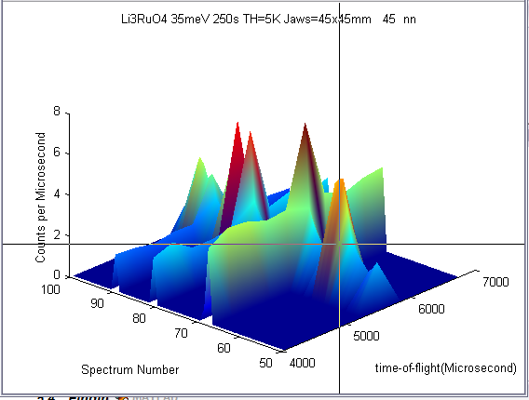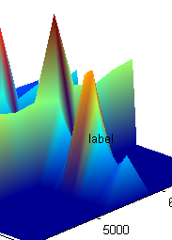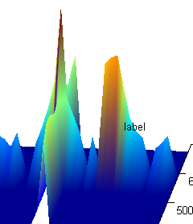
(a) (b) (c)

Figure 3: Demonstration of dxyz command – showing a surface and (a) position of cursor when clicked, (b) label on resultant point found, (c) rotation to demonstrate the position in 3 dimensions.

If used on a 1d graph then z values will all be 0, one can call the function without the z output variable if required.

Property | Possible Value | Behaviour | Default
‘text’ | Any string value | Text is added to the selected point | BLANK
‘no_points’ | Any numeric value | Defines the number of points which are to be selected on the plot. Once ‘no_points’ number of points have been selected, the function will end. If left blank, this has the same as the default behaviour. | Infinite
‘display_coords’ | True or false | If true, then the co-ordinates of the points selected will be placed on the graph at the selected points. If text is given as well, the co-ordinates will be appended to the end of the text. | False
‘closest_point’ | True or false | The co-ordinates of the closest actual point of data is returned as the point | False

Example:

>> [x,y,z] = dxyz (‘text’,’mytext’,’display_coords’,true,’no_points’,5)

Will record the x,y,z co-ordinates at the point clicked and place the text

“mytext (x, y, z)”

Where x,y,z are the x,y and z coordinates at that point. The user can selected up to 5 points.

Keep Figure

All plots of a certain type (defined by the combination of the name and tag of the graph) will plot into the same window and replace the current plot. If you want to keep the plot of any window you can use the keep figure command.

>> kf Keeps the current figure
>> kf (fig_no) Keeps figure number fig_no

Any figure which is currently being kept will have “(HOLD)” in the titlebar. Commands such as

>> lx
>> logx

Will still work, but no new plots will be made to the figure.

Release Figure

Releases a kept figure, effectively the opposite.

>> rf releases the current figure
>> rf (fig_no) releases figure number fig_no

set_plot, set_axes, set_figure

>> set_figure (identifier, ‘attribute’, ’value’)

These can be used to set the axes, plot and figure properties respectively. All the commands accept the nametag (the name, followed by the tag with no spaces in-between), the figure number, axes handle or plot handle as the identifier. For instance,

>> set_plot(1, ’color’, ’blue’)

will set all plots within figure 1 to the colour blue, while

>> set_axes (‘default one dimensional plot’, ‘xlabel’, ’x data’)

Will set the axes x-label to ‘x data’ in the plot with the nametag ‘default one dimensional plot’.

>> [myfigure, myaxes, myplot] = dl(w)
>> [myfigure, myaxes, myplot2] = pl(w2)
>> set_plot (myplot2, ‘marker’, ‘o’)

Will set the marker style on the second line only ‘o’ and is equivalent to the matlab set command.

>> set_figure(myplot2, ’tag’, ’figure tag’)

And

>> set_figure(myplot, ’tag’, ’figure tag’)

Are equivalent, since both myplot and myplot2 are contained within the same figure. These commands make formatting plots simpler than the matlab set command, you do not need to know all the handles to a plot to be able to change it.

All attributes of a graph which can be set using the matlab set command can be set this way, a non-exhaustive list is given in the user reference.

Set legend (sl)

>> sl (‘string1’, ‘string2’)

Puts a legend on the current one dimensional plot using the strings provided. Plots are named in reverse order to their creation (i.e. most recent plot is named first)

Other Commands

Reset Default

>> rd

This will reset the future properties of the current graph type (as determined by the name, tag combination) to the properties for all graphs.

Reset All

>> ra

This will reset the future properties of all future graphs to the default properties.

gallnt (get all name tags)

>> [names tags] = gallnt

This will return all the names and all the tags currently open in figures.

gallh (get all handles)

>> [figures, axes, plots, other] = gallh(ident)
>> [figures, axes, plots, other] = gallh

Will get the figure, axes, plot and other handles of all open plots which relate to ident (where ident is an identifier – see online help for more information)

undop (undo plot)

>> undop

This will remove the last plot that was made in the current figure

Color_slider

>> color_slider (figureHandle_)

This will add sliders to the top and bottom of a colorbar on the graph. Intended for 2d area plots (but can be used on surface plots), these sliders will change the colour scale of the graph by increasing or decreasing the bottom or top of the scale.

If no figure handle is given, then the current figure is used.

Rename

>> rename (figureH, ‘new_name’, ‘new_tag’)

This will rename the figure with the handle figureH to the new name and tag given. All the current defaults and properties will be copied to the new name and tag. This should be used instead of directly altering the names and tags of plots.

Fromplot

>> dataset = fromplot (figure)
>> dataset = fromplot (‘property’, ‘value’…)
>> dataset = fromplot (figure, ‘property’, ‘value’,…)

This will get as much data from a plot identified by the handle given, (by default this will be the current figure) and put it into an IXTdataset_2d object. If an IXTdataset_1d object array is required, the output can be expanded using the command

>> expand_d1d (d2d)

Optional property-value pairs can be given to over-ride automatically filled properties. For instance, one might want to change the title of a plot by typing:

>> fromplot (‘title’, ’copied plot’)

The properties that can be set are the same as the field names in an IXTdataset_2d (see below)

Field Name | Possible Value | Default Value
title | Any string value | The title of the plot
x_units | Any IXTunits object | IXTunits object with units code ‘null’ and units from the xlabel of the plot
y_units | Any IXTunits object | IXTunits object with units code ‘null’ and units from the xlabel of the plot
s_units | Any IXTunits object | IXTunits object with units code ‘null’ and units from the xlabel of the plot
x | Single numeric array | XData from plot (all x data regardless of limits)
y | Single numeric array | YData from plot (all y data regardless of limits) if there are 3 axes, “1” if not
signal | Length(x) x length(y) array | ZData from plot if there are 3 axes, if 2 then YData from plot.
error | Length(x) x length(y) array | Zeros the size of the signal data
x_distribution | True or false | False
y_distribution | True or false | False

Set default property - sdp

>> sdp ( name, tag, property1, value1, property2, value2,…)

This sets the default properties of particular name tags. The next graph plotted with that name tag will take the properties set in sdp by default (along with the global defaults).

Example:

>> sdp(‘myplot’, ‘fortoby’, ‘color’, ‘green’, ‘acolor’, ‘black’)

This will set any plots given the name “myplot” and tag “fortoby” to plot colour green and axes colour black.

Set User Preferences – sup

>> sup (‘property’,’value’,’property’,’value’,...)

This sets the global defaults for various properties. Global defaults are used by all plots and name tags. This differs from sdp – which sets the defaults for a specific name tag only (plots will take passed properties first, then name-tag defaults, then global defaults).

Example:

>> sup (‘color’,’red’,’acolor’,’blue’)

All future plots will use the plot colour red and axes color blue by default.

Check Figure – chkf

>> handle = chkf(handle, name, tag)

This command will check that the current figure has the given name and tag combination. This is useful when, for example, scripting other applications which use the graphics packagae. It can be used as a check that the figure handle passed is part of application or has been created by another application.

The returned handle will be the input handle if the figure is part of the application. If not, then the returned handle will be 0.

Example:

>> check = chkf(3, ‘Toby’, ‘plot’)

Will return 3 if figure 3 has the name ‘Toby’ and the tag ‘plot’.

Get Handle – gh

>> handle_ = gh(name, tag)

This differs from gallh, as it only returns the figure handle of an unheld figure. The returned handle will be the figure handle of all unheld figures with the name ‘name’ and tag ‘tag’.

Example:

>> dl(w1)
>> kf
>> dl(w2)
>> handle = gh(‘default one dimensional plot’, ‘’)

Handle will be 2, since the first figure is held and the second figure is a default one dimensional plot (since I didn’t give it a name or tag when plotting).

Alias

>> alias(‘function old’, ‘function new’, ‘comments to add’)

This will create a function called ‘function new’ which will simply call the function ‘function_old’ allowing one to create an alias for the function (i.e. a name which can be used as well as the original). Comments will be added to help (gtkhelp).

Example:

>> alias(‘ds’,’surface_plot’,’longer name for surface plot’)

One would now be able to do a surface plot by typing ds or surface_plot.

Set Current Figure (scf)

>> scf (‘name’,’tag’)
>> scf (handle, ‘name’, ‘tag’)
>> scf (handle)

Is used to set the current figure. Most useful when given a name and tag. A return value is optional and will return the handle if a figure is found, a 0 if not. The selected figure will be the first unheld figure which matches the passed properties.

FAQ and Support

Online Help

For a list of functions type

>> gkthelp

Online help for all GTK functions is available by typing

>> help ‘function’

where ‘function’ is the name of the function you require help with. This will give you the syntax, optional arguments and restrictions of the function.

User Reference

For more information on any commands, read the user reference in the documentation. It contains full detailed information about all user commands.

FAQ

Submit any questions using the libisis website:

https://www.libisis.org

Technical Support

For all help, suggestions and support use the libisis website

https://www.libisis.org

